HIGH SCHOOL MATH ACHIEVEMENT
48.3% were male students, 48.7% were female students. Gender for 13 students was not recorded.
Gender | Frequency | Percentage
Male | 207 | 48.3
Female | 209 | 48.7
Missing | 13 | 3.0

Among the 439 students, only 22.6% were in AP math class. 62.9% were not in the class while recoed for 62 students was missing.
Whether students are in AP math class | Frequency | Percent
Yes | 97 | 22.6
No | 270 | 62.9
Missing | 62 | 14.5

Of the 429 students, 24.9% were black, 35.4% were Hispanic, 21.4% were white, 4.2% were Asian,10.3% were other minority races. Information concerning 16 students were 3.7%.
Race | Frequency | Percent
Black | 107 | 24.9
Hispanic | 152 | 35.4
White | 92 | 21.4
Asian | 18 | 4.2
Other Minority | 44 | 10.3
Missing | 16 | 3.7

The highest proportion (9.6%) of students identify with mathematics at level 6. The mean level was 5.27 with a standard deviation of 1.32.
Mean | 5.2745
Std. Deviation | 1.31946

Math Identification | Frequency | Percent
1.00 | 6 | 1.4
1.33 | 1 | 0.2
1.40 | 1 | 0.2
1.50 | 1 | 0.2
1.60 | 1 | 0.2
1.67 | 2 | 0.5
1.83 | 1 | 0.2
2.17 | 2 | 0.5
2.67 | 8 | 1.9
2.83 | 6 | 1.4
3.00 | 1 | 0.2
3.17 | 6 | 1.4
3.20 | 1 | 0.2
3.33 | 6 | 1.4
3.40 | 1 | 0.2
3.50 | 2 | 0.5
3.67 | 7 | 1.6
3.80 | 1 | 0.2
3.83 | 11 | 2.6
4.00 | 11 | 2.6
4.17 | 9 | 2.1
4.33 | 12 | 2.8
4.50 | 10 | 2.3
4.67 | 15 | 3.5
4.83 | 14 | 3.3
5.00 | 18 | 4.2
5.17 | 21 | 4.9
5.20 | 1 | 0.2
5.33 | 20 | 4.7
5.50 | 22 | 5.1
5.60 | 1 | 0.2
5.67 | 17 | 4.0
5.80 | 1 | 0.2
5.83 | 27 | 6.3
6.00 | 41 | 9.6
6.17 | 20 | 4.7
6.20 | 1 | 0.2
6.33 | 18 | 4.2
6.50 | 20 | 4.7
6.60 | 1 | 0.2
6.67 | 21 | 4.9
6.83 | 14 | 3.3
7.00 | 28 | 6.5

The highest proportion (10%) of students rated gender stigma consciousness at 4. The mean level was 3.75 with a standard deviation of 1.32.
Mean | 3.7493
Std. Deviation | 1.32194

GS | Frequency | Percent
1.00 | 14 | 3.3
1.20 | 4 | .9
1.25 | 1 | .2
1.40 | 5 | 1.2
1.60 | 7 | 1.6
1.80 | 9 | 2.1
2.00 | 17 | 4.0
2.20 | 9 | 2.1
2.25 | 1 | .2
2.40 | 17 | 4.0
2.50 | 2 | .5
2.60 | 11 | 2.6
2.75 | 1 | .2
2.80 | 18 | 4.2
3.00 | 14 | 3.3
3.20 | 13 | 3.0
3.25 | 1 | .2
3.33 | 1 | .2
3.40 | 25 | 5.8
3.50 | 1 | .2
3.60 | 20 | 4.7
3.75 | 1 | .2
3.80 | 23 | 5.4
4.00 | 43 | 10.0
4.20 | 26 | 6.1
4.25 | 2 | .5
4.40 | 17 | 4.0
4.60 | 20 | 4.7
4.67 | 1 | .2
4.80 | 17 | 4.0
5.00 | 22 | 5.1
5.20 | 15 | 3.5
5.40 | 17 | 4.0
5.50 | 1 | .2
5.60 | 6 | 1.4
5.75 | 1 | .2
5.80 | 6 | 1.4
6.00 | 4 | .9
6.20 | 6 | 1.4
6.60 | 3 | .7
6.80 | 2 | .5
7.00 | 4 | .9

Of the 429 students, a high proportion of them (8.9%) rated ethnic identification at 7. The mean ethnic identification was 5.03 with a standard deviation of 1.37.
Mean | 5.0306
Std. Deviation | 1.36992

EI | Frequency | Percent
1.00 | 4 | .9
1.25 | 2 | .5
1.50 | 2 | .5
1.75 | 3 | .7
2.00 | 3 | .7
2.25 | 6 | 1.4
2.50 | 7 | 1.6
2.75 | 3 | .7
3.00 | 7 | 1.6
3.25 | 8 | 1.9
3.33 | 2 | .5
3.50 | 14 | 3.3
3.67 | 1 | .2
3.75 | 12 | 2.8
4.00 | 36 | 8.4
4.25 | 23 | 5.4
4.33 | 1 | .2
4.50 | 24 | 5.6
4.75 | 26 | 6.1
5.00 | 28 | 6.5
5.25 | 23 | 5.4
5.33 | 2 | .5
5.50 | 30 | 7.0
5.75 | 28 | 6.5
6.00 | 30 | 7.0
6.25 | 24 | 5.6
6.33 | 1 | .2
6.50 | 15 | 3.5
6.67 | 1 | .2
6.75 | 23 | 5.4
7.00 | 38 | 8.9

Majority of the students (7.7%) rated ethnic stigma at 3.8. The mean Ethnic Stigma was 3.62 with a standard deviation of 1.33.

Mean | 3.6275
Std. Deviation | 1.32930

Ethnicity Stigma | Frequency | Percent
1.00 | 16 | 3.7
1.20 | 8 | 1.9
1.40 | 9 | 2.1
1.50 | 1 | .2
1.60 | 10 | 2.3
1.75 | 3 | .7
1.80 | 6 | 1.4
2.00 | 10 | 2.3
2.20 | 12 | 2.8
2.40 | 9 | 2.1
2.50 | 3 | .7
2.60 | 16 | 3.7
2.75 | 1 | .2
2.80 | 25 | 5.8
3.00 | 13 | 3.0
3.20 | 16 | 3.7
3.25 | 3 | .7
3.40 | 20 | 4.7
3.50 | 1 | .2
3.60 | 22 | 5.1
3.67 | 1 | .2
3.75 | 3 | .7
3.80 | 33 | 7.7
4.00 | 30 | 7.0
4.20 | 26 | 6.1
4.25 | 2 | .5
4.33 | 1 | .2
4.40 | 12 | 2.8
4.50 | 6 | 1.4
4.60 | 18 | 4.2
4.75 | 2 | .5
4.80 | 16 | 3.7
5.00 | 16 | 3.7
5.20 | 16 | 3.7
5.25 | 1 | .2
5.40 | 8 | 1.9
5.50 | 1 | .2
5.60 | 9 | 2.1
5.75 | 2 | .5
5.80 | 3 | .7
6.00 | 5 | 1.2
6.20 | 3 | .7
6.40 | 2 | .5
6.50 | 2 | .5
6.60 | 1 | .2
7.00 | 4 | .9

The mode level of negative affect was 2.67, 3, 4, 4.17. The mean was 3.84 with a standard deviation of 1.30.
Mean | 3.8479
Std. Deviation | 1.30306

 | Frequency | Percent
1.00 | 3 | .7
1.33 | 1 | .2
1.50 | 2 | .5
1.67 | 4 | .9
1.83 | 8 | 1.9
2.00 | 18 | 4.2
2.17 | 18 | 4.2
2.33 | 11 | 2.6
2.50 | 17 | 4.0
2.60 | 1 | .2
2.67 | 20 | 4.7
2.80 | 1 | .2
2.83 | 10 | 2.3
3.00 | 20 | 4.7
3.17 | 13 | 3.0
3.33 | 20 | 4.7
3.50 | 19 | 4.4
3.60 | 2 | .5
3.67 | 15 | 3.5
3.83 | 18 | 4.2
4.00 | 20 | 4.7
4.17 | 20 | 4.7
4.33 | 18 | 4.2
4.50 | 17 | 4.0
4.67 | 8 | 1.9
4.83 | 13 | 3.0
5.00 | 10 | 2.3
5.17 | 15 | 3.5
5.20 | 1 | .2
5.33 | 12 | 2.8
5.50 | 12 | 2.8
5.60 | 1 | .2
5.67 | 14 | 3.3
5.83 | 8 | 1.9
6.00 | 9 | 2.1
6.17 | 7 | 1.6
6.33 | 2 | .5
6.50 | 1 | .2
6.67 | 3 | .7
6.83 | 2 | .5
7.00 | 2 | .5

Male and female students do not identify with mathematics differently. There is no difference in male and female students in maths identification.
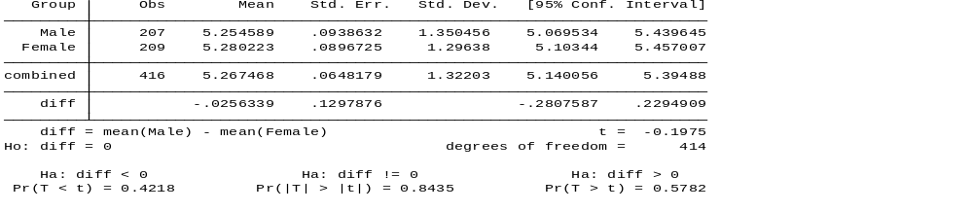

There is a significant difference between male and female students in negative affect. Female students have a greater negative affect compared to male students.
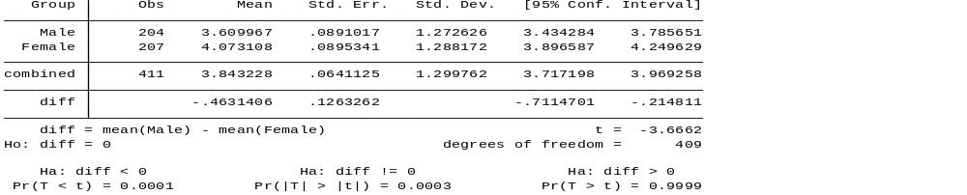

At least one of the ethnic groups is significantly different from the rest. From the post hoc analysis, white is significantly different from black ethic group.

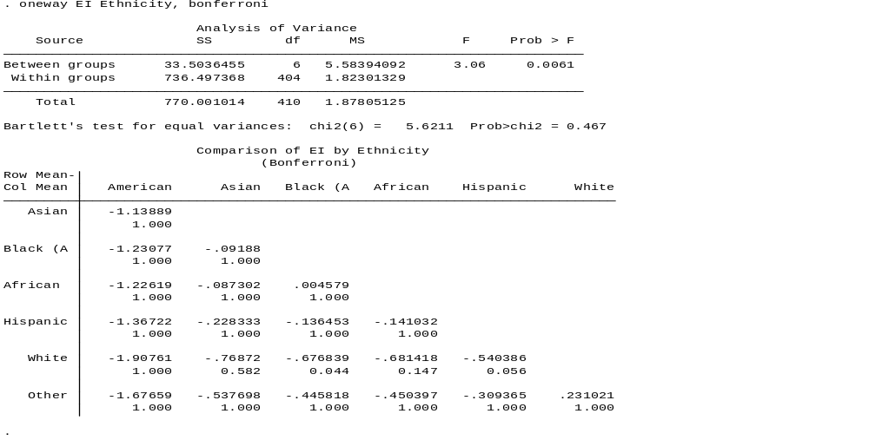
The table below shows that at least one ethnic group is different from the other in terms of ES. Post hoc test shows that white ethnic group is significantly different from African and Hispanic ethnic groups.
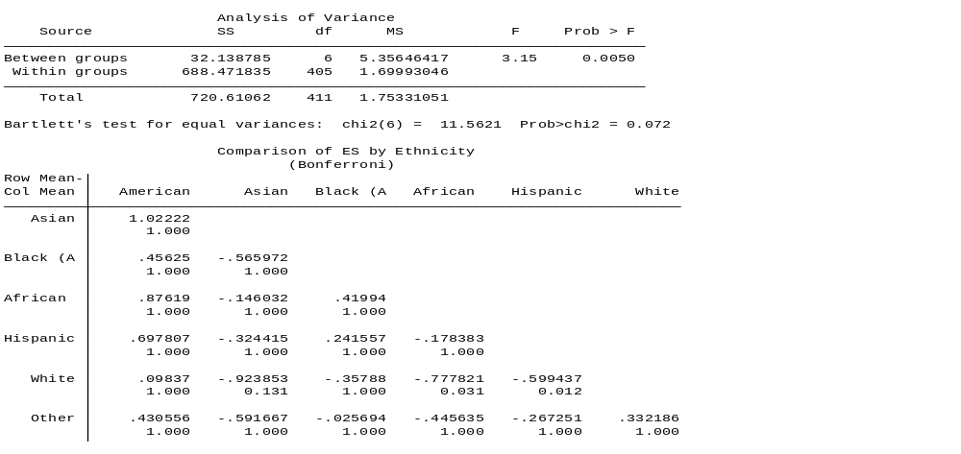
The table below indicates that there is no significant difference between ethnic groups in terms of negative affluence.

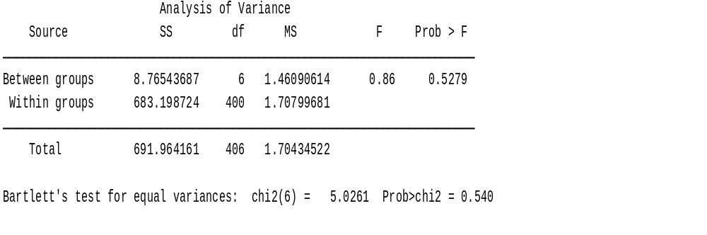
The table below shows that there is no association between a student being in AP math class and test scores in maths reflecting their true math potential.
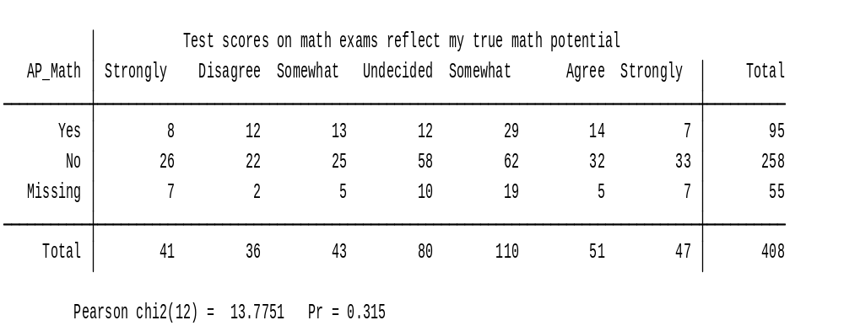
The table below shows that there is no association between a student being in AP math class and whether a student does better in homework than on exams.
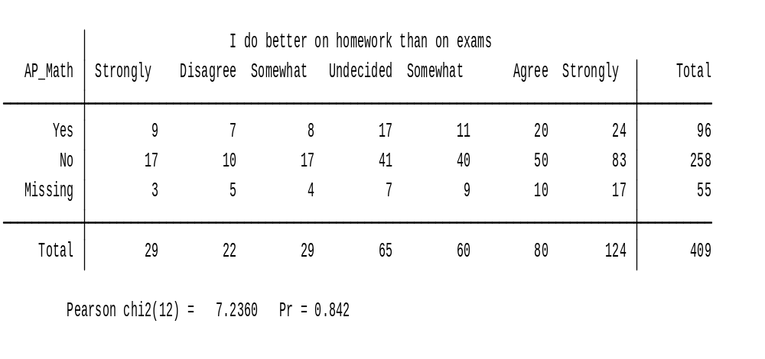
The table below shows that there is no association between ethnicity of a student and test scores in maths reflecting their true math potential.

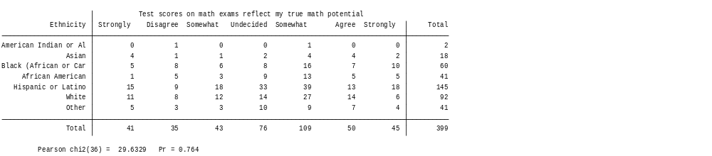

The table below shows that there is no association between ethnicity of a student and whether a student does better in homework than on exams.

